Practical-4
Name:- Shubham Sonawane
Roll no-4401058
Div-A Batch-D
#define BLYNK_TEMPLATE_ID "TMPL3WKv0Zi_b"
#define BLYNK_TEMPLATE_NAME "PWM Speed control"
#define BLYNK_AUTH_TOKEN "h76QQxBM07VW3mdl9Eu_S9LRdb1XHntw"
#define BLYNK_PRINT Serial
#include <ESP8266WiFi.h>
#include <BlynkSimpleEsp8266.h>
// Wi-Fi credentials
char ssid[] = "Chetan";
char pass[] = "12341234";
// Motor pins
const int motorPin1 = D1; // IN1
const int motorPin2 = D2; // IN2
const int enablePin = D3; // ENA (PWM)
// Motor speed variable
int motorSpeed = 0; // 0-1023 PWM
// ------------------- Blynk Virtual Pin -------------------
BLYNK_WRITE(V0) // Slider 0-100
{
int speedPercent = param.asInt();
speedPercent = constrain(speedPercent, 0, 100);
motorSpeed = map(speedPercent, 0, 100, 0, 1023);
Serial.print("Slider received: "); Serial.println(speedPercent);
applyMotor();
}
// ------------------- Setup & Loop -------------------
void setup()
{
Serial.begin(115200);
pinMode(motorPin1, OUTPUT);
pinMode(motorPin2, OUTPUT);
pinMode(enablePin, OUTPUT);

analogWriteRange(1023);
analogWriteFreq(1000);
// Always forward
digitalWrite(motorPin1, HIGH);
digitalWrite(motorPin2, LOW);
// Start motor stopped
analogWrite(enablePin, 0);
Serial.println("Connecting to Wi-Fi and Blynk...");
Blynk.begin(BLYNK_AUTH_TOKEN, ssid, pass);
}
void loop()
{
Blynk.run();
}
// ------------------- Motor function -------------------
void applyMotor() {
analogWrite(enablePin, motorSpeed);
Serial.print("Motor speed (PWM): "); Serial.println(motorSpeed);
}

OUTPUT:
Serial Monitor-
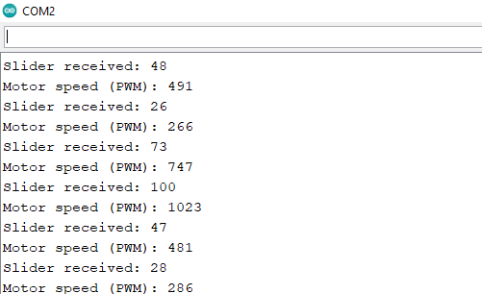

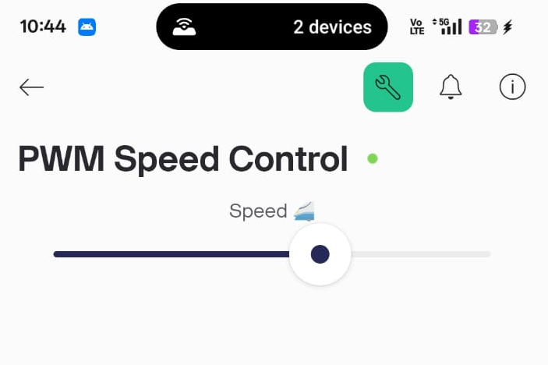
Control Page:
Hardware Output:
